Storage Metrics

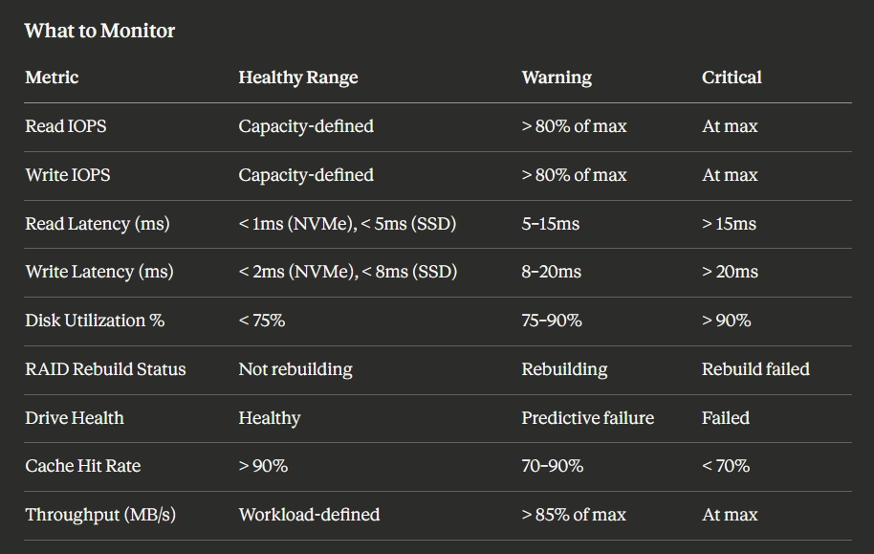

Metrics WE CAN IMPLEMENT

Core Storage Metrics

🔹 1. Read IOPS ✅
- From: node_disk_reads_completed_total

🔹 2. Write IOPS ✅
- From: node_disk_writes_completed_total

🔹 3. Throughput (MB/s) ✅
- From:
  - node_disk_read_bytes_total
  - node_disk_written_bytes_total

🔹 4. Read Latency ✅
- Derived:
  - read_time / read_ops

🔹 5. Write Latency ✅
- Derived:
  - write_time / write_ops

🔹 6. Disk Utilization % ✅
- From:
  - node_disk_io_time_seconds_total

Metrics WE CANNOT IMPLEMENT (in our setup)

❌ RAID Rebuild Status
- Needs multiple disks + RAID controller

❌ Drive Health (SMART-level)
- Needs hardware-level access

❌ Cache Hit Rate
- Needs storage controller / enterprise system

